UNIT 4 – LAB EXPERIMENTS

COURSE CODE: CSA1610 COURSE NAME: DWDM
P Sai Rakesh Reddy
(192365060)
EXPERIMENT NO. 1
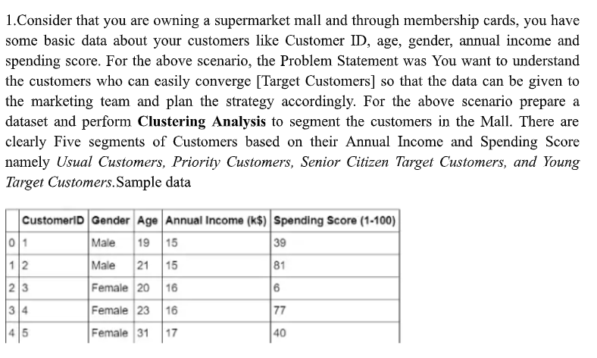
@relation mall_customer_segmentation

@attribute CustomerID numeric
@attribute Gender {Male,Female}
@attribute Age numeric
@attribute AnnualIncome numeric
@attribute SpendingScore numeric

@data
1,Male,19,15,39
2,Male,21,15,81
3,Female,20,16,6
4,Female,23,16,77
5,Female,31,17,40
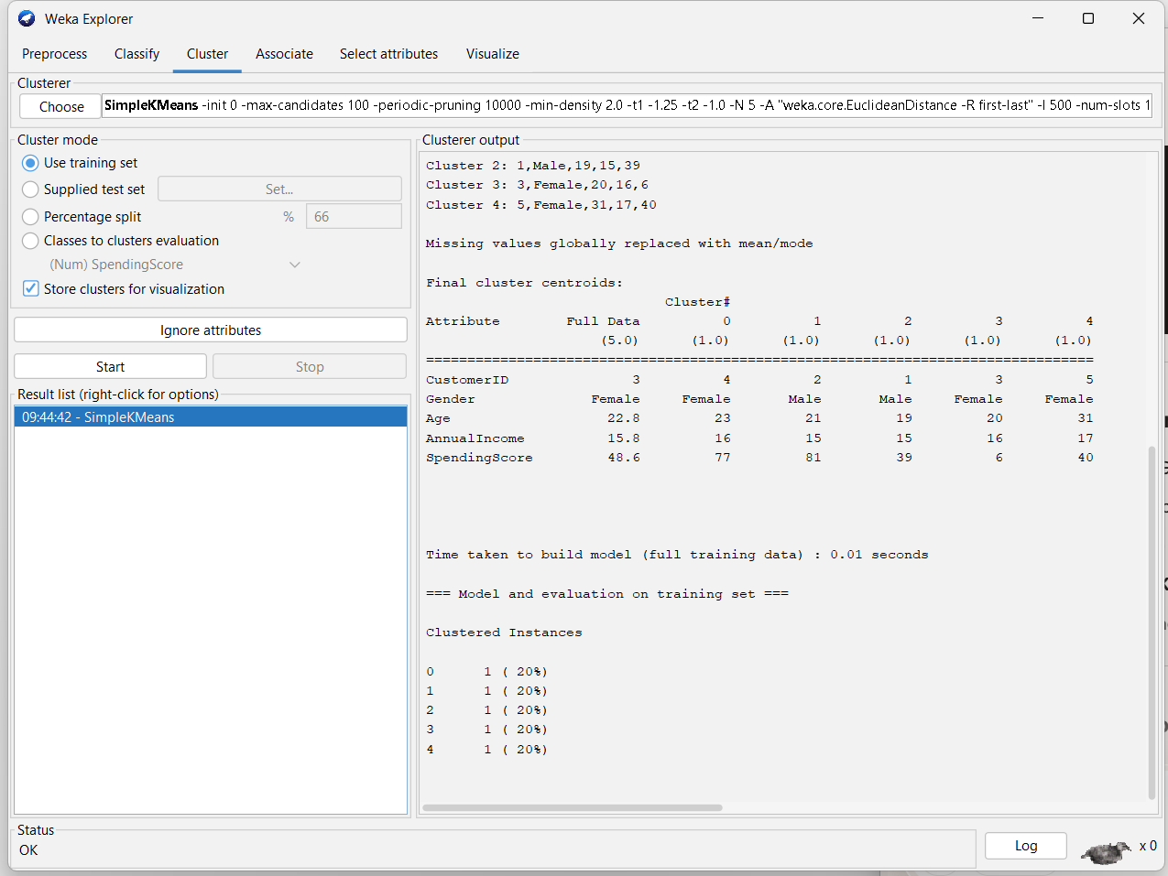
EXPERIMENT NO.: 2
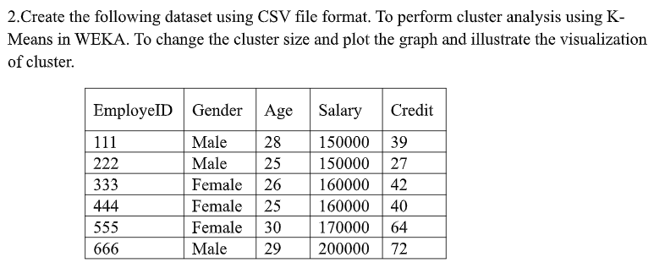
@relation employee_cluster_analysis

@attribute EmployeeID numeric
@attribute Gender {Male,Female}
@attribute Age numeric
@attribute Salary numeric
@attribute Credit numeric

@data
111,Male,28,150000,39
222,Male,25,150000,27
333,Female,26,160000,42
444,Female,25,160000,40
555,Female,30,170000,64
666,Male,29,200000,72
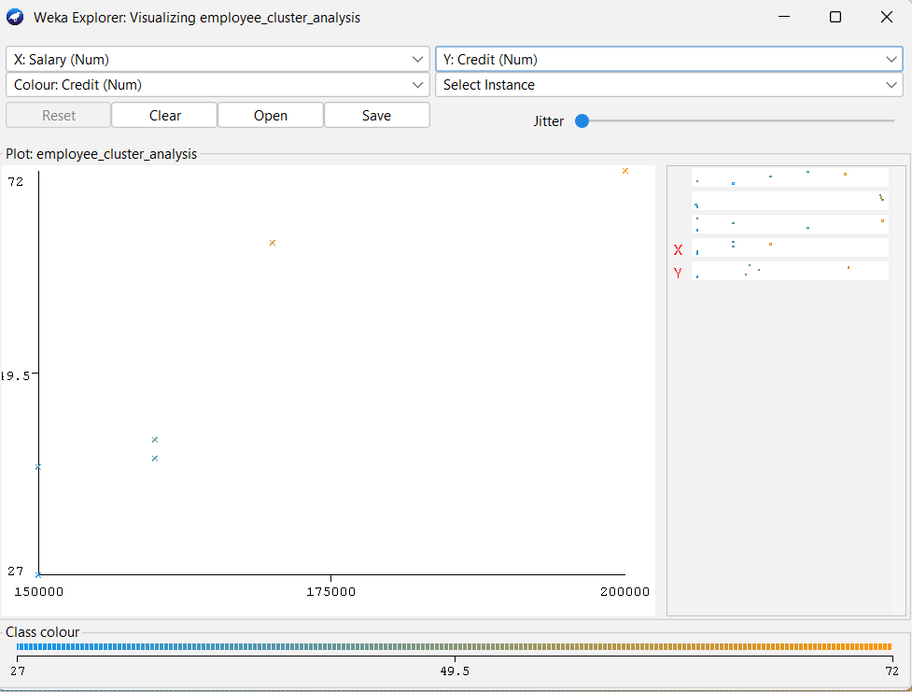
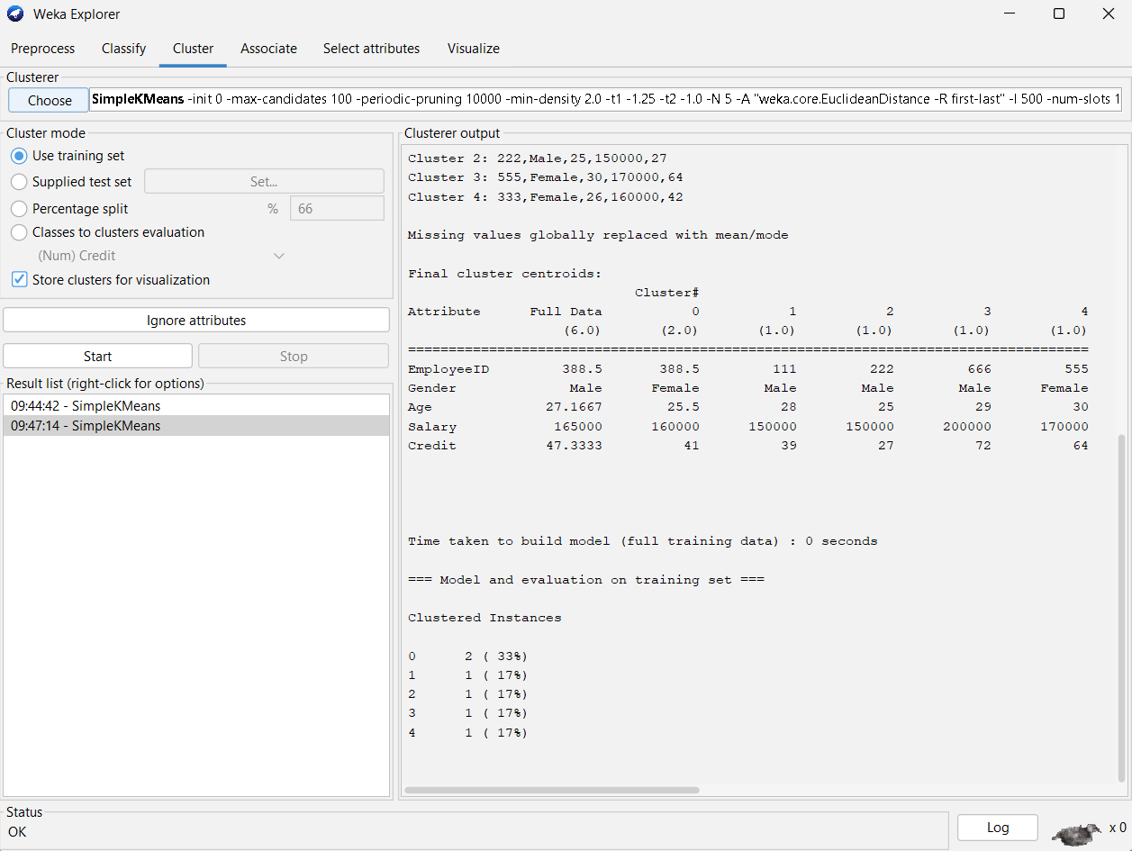
EXPERIMENT NO.: 3
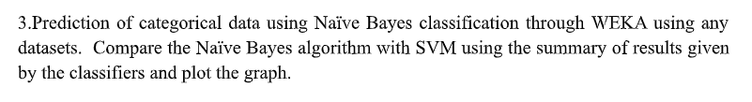
@relation student_performance

@attribute StudyHours {low,medium,high}
@attribute Attendance {poor,average,good}
@attribute Result {pass,fail}

@data
low,poor,fail
low,average,fail
medium,average,pass
medium,good,pass
high,good,pass
high,average,pass
low,good,fail
medium,poor,fail
high,poor,pass
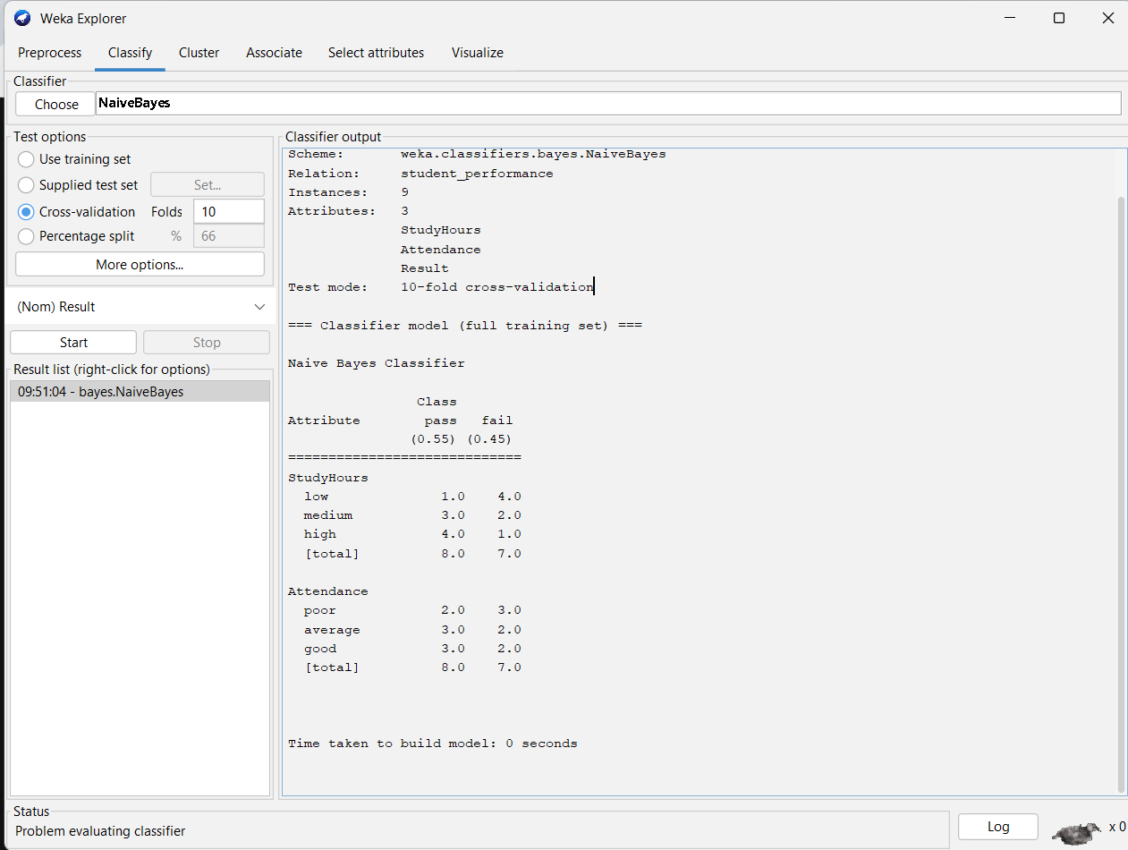
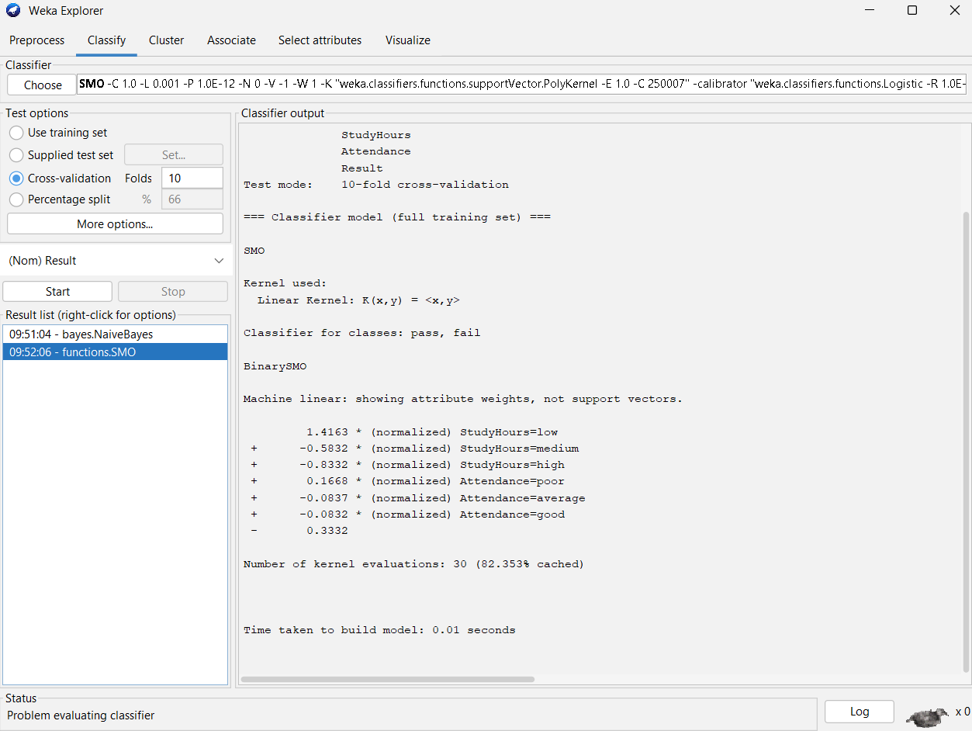
EXPERIMENT NO.: 4
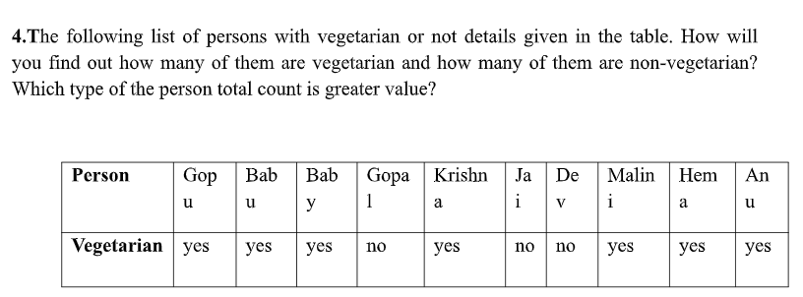
@relation vegetarian_analysis

@attribute Person string
@attribute Vegetarian {yes,no}

@data
Gopu,yes
Babu,yes
Baby,yes
Gopal,no
Krishna,yes
Jai,no
Dev,no
Malini,yes
Hema,yes
Anu,yes
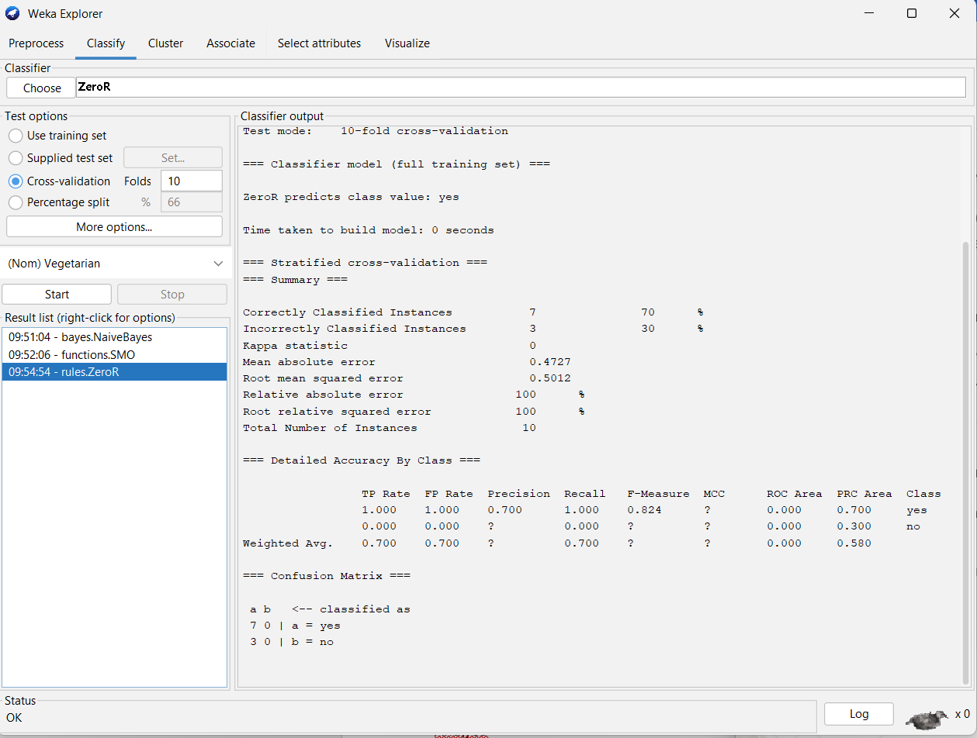
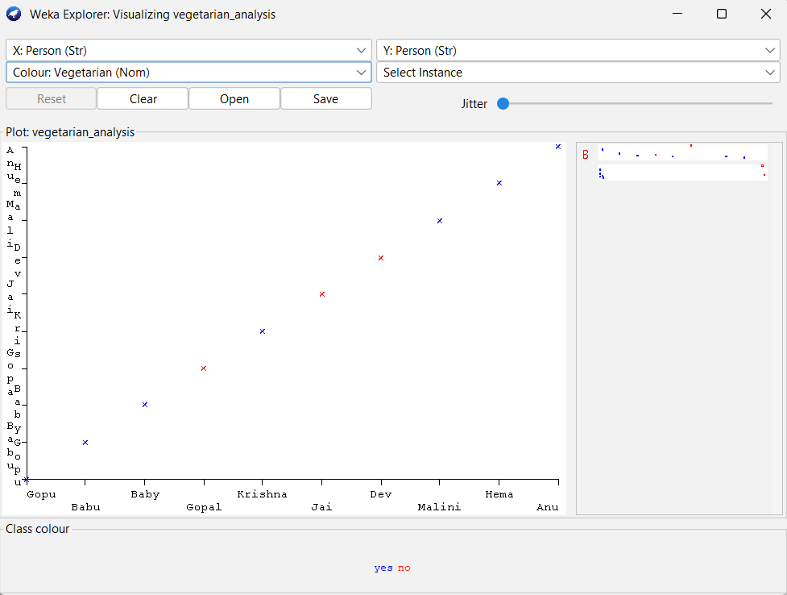
EXPERIMENT NO.: 5
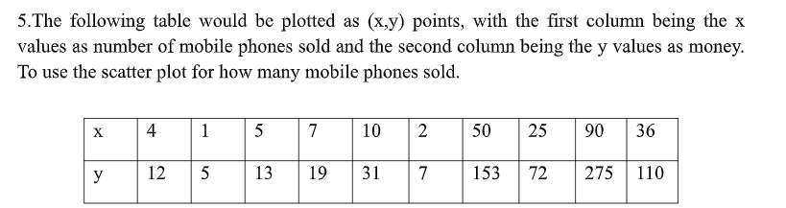
@relation mobile_sales

@attribute PhonesSold numeric
@attribute Money numeric

@data
4,12
1,5
5,13
7,19
10,31
2,7
50,153
25,72
90,275
36,110
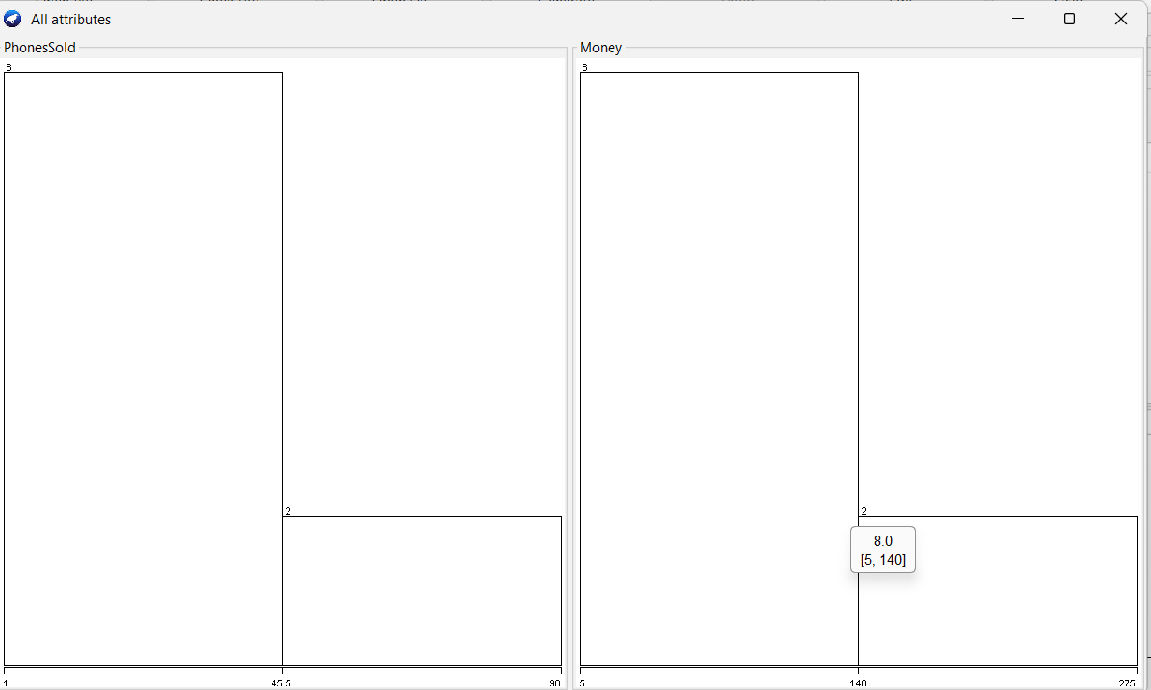

EXPERIMENT NO.: 6
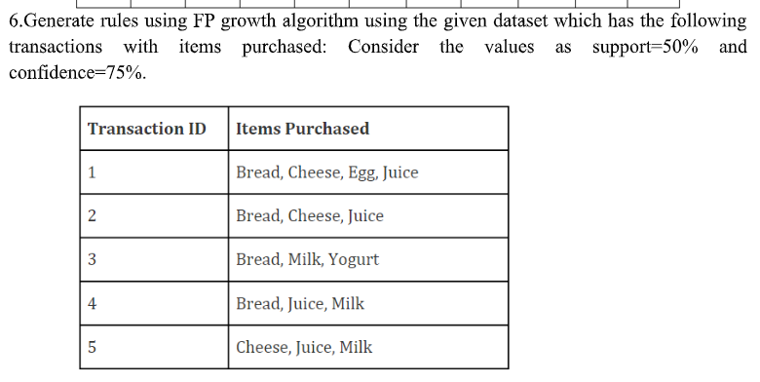
@relation items

@attribute Bread {t,f}
@attribute Cheese {t,f}
@attribute Egg {t,f}
@attribute Juice {t,f}
@attribute Milk {t,f}
@attribute Yogurt {t,f}

@data
t,t,t,t,f,f
t,t,f,t,f,f
t,f,f,f,t,t
t,f,f,t,t,f
f,t,f,t,t,f
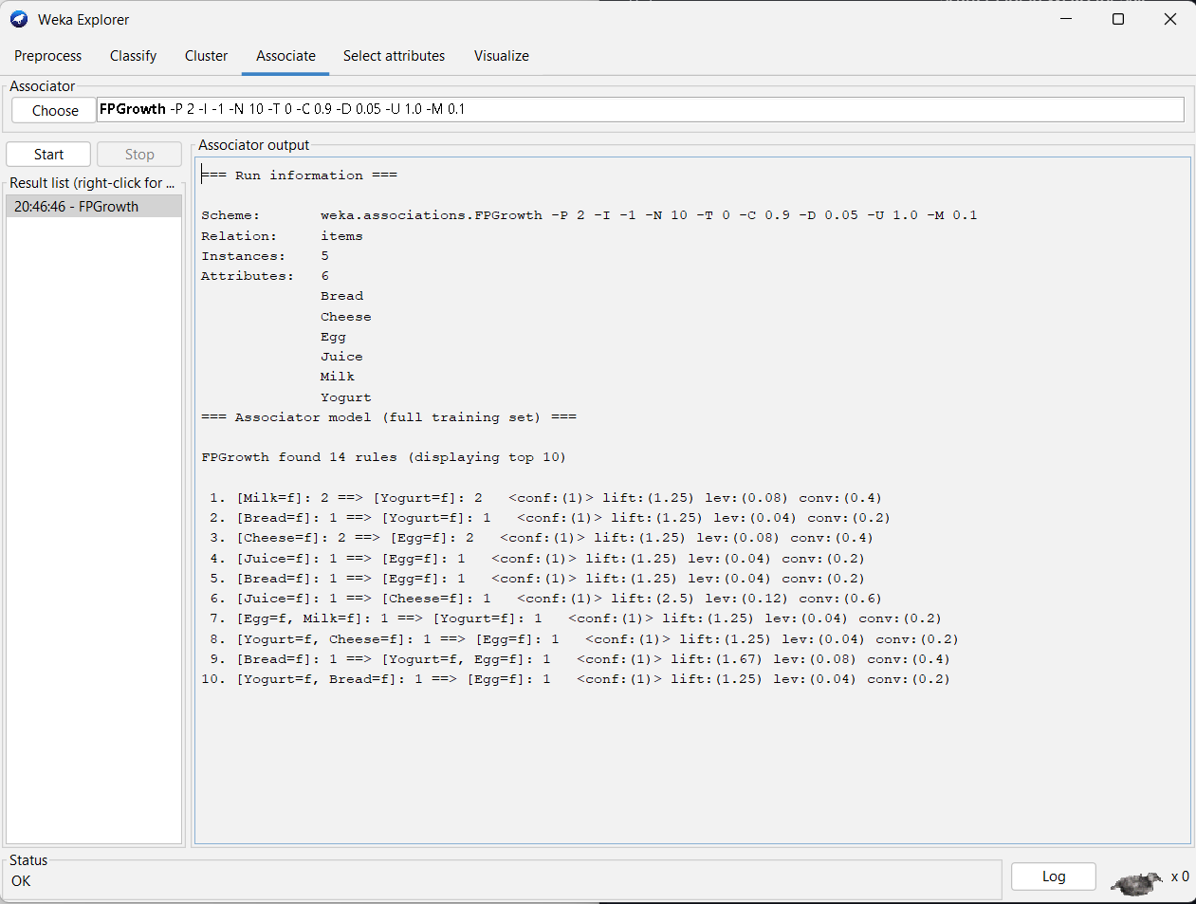
EXPERIMENT NO.:7
@relation diabetes

@attribute Pregnancies numeric
@attribute Glucose numeric
@attribute BloodPressure numeric
@attribute SkinThickness numeric
@attribute Insulin numeric
@attribute BMI numeric
@attribute DiabetesPedigreeFunction numeric
@attribute Age numeric
@attribute Outcome {tested_positive, tested_negative}

@data
6,148,72,35,0,33.6,0.627,50,tested_positive
1,85,66,29,0,26.6,0.351,31,tested_negative
8,183,64,0,0,23.3,0.672,32,tested_positive
1,89,66,23,94,28.1,0.167,21,tested_negative
0,137,40,35,168,43.1,2.288,33,tested_positive
5,116,74,0,0,25.6,0.201,30,tested_negative
3,78,50,32,88,31.0,0.248,26,tested_positive
10,115,0,0,0,35.3,0.134,29,tested_negative
2,197,70,45,543,30.5,0.158,53,tested_positive
8,125,96,0,0,0.0,0.232,54,tested_negative
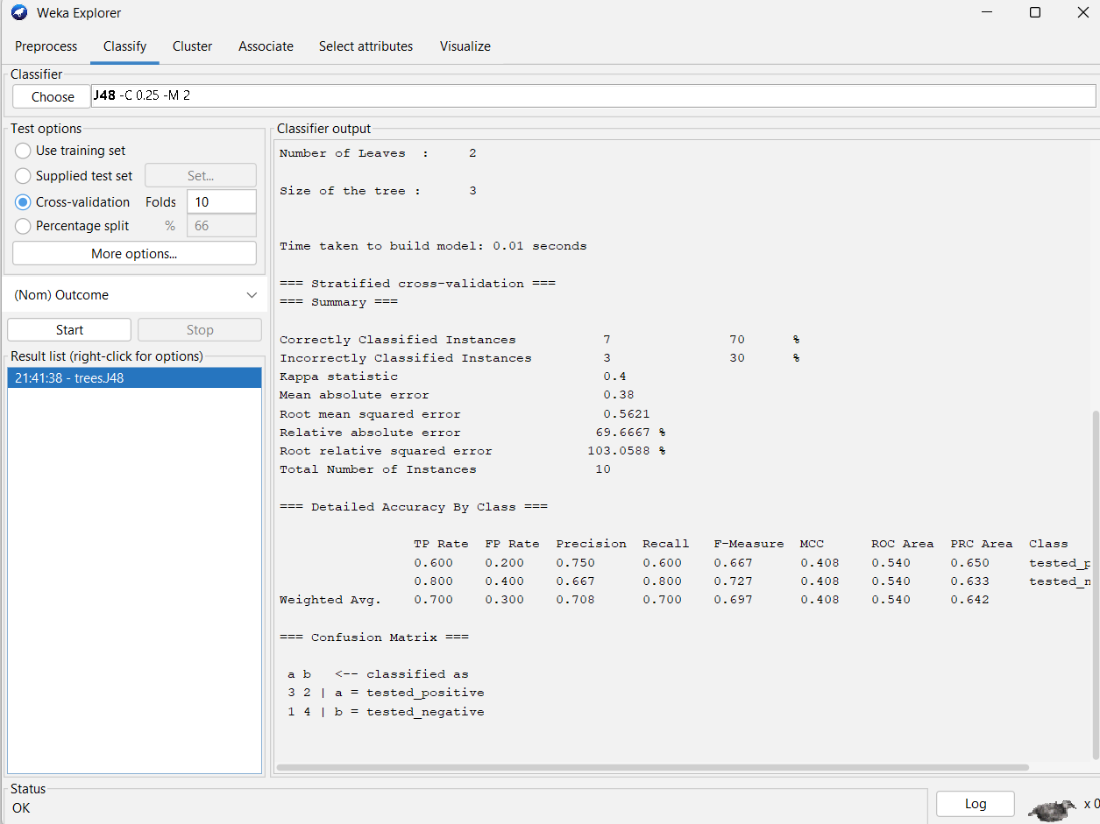
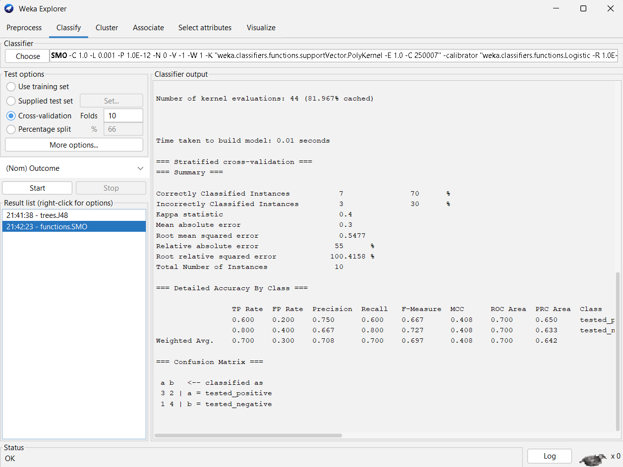
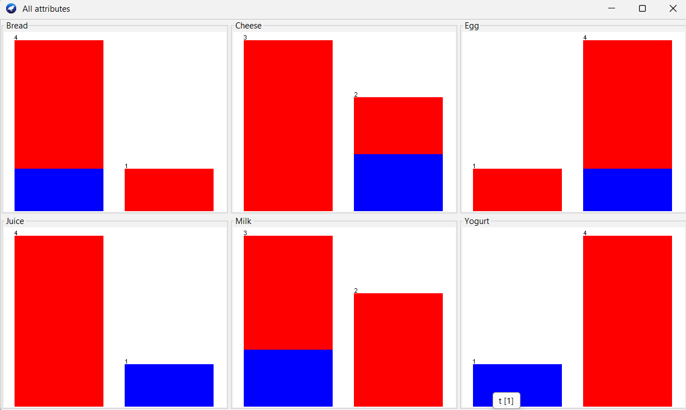
EXPERIMENT NO.:8
@relation marks_partition

@attribute Marks numeric

@data
55
60
71
63
55
65
50
55
58
59
61
63
65
67
71
72
75
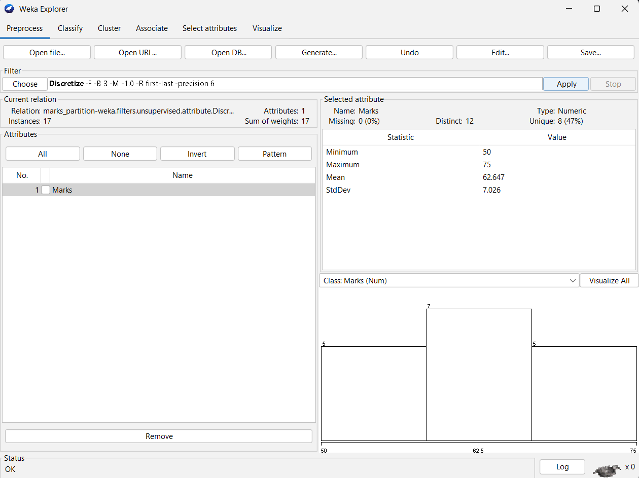
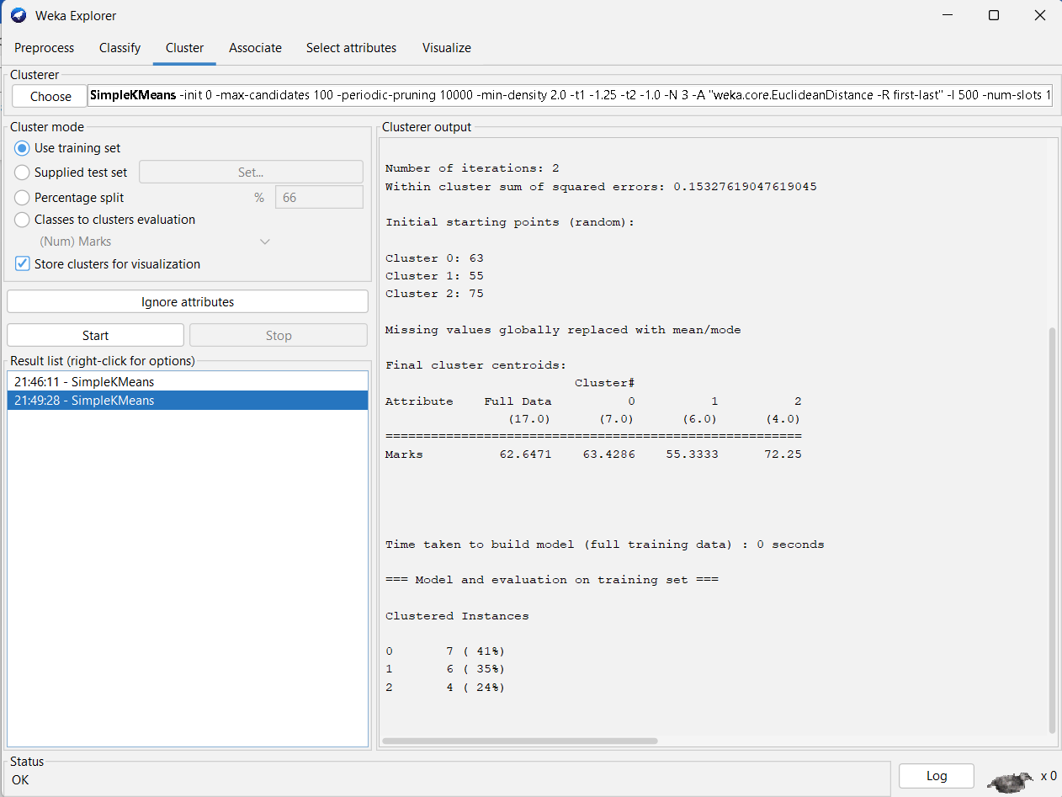
EXPERIMENT NO.:9
@relation gender_decision

@attribute Height numeric
@attribute Weight numeric
@attribute Gender {Male,Female}

@data
185,70,Male
190,85,Male
175,90,Male
160,55,Female
170,60,Female
165,75,Female
182,82,Male
178,78,Female
185,95,Male
172,65,Female
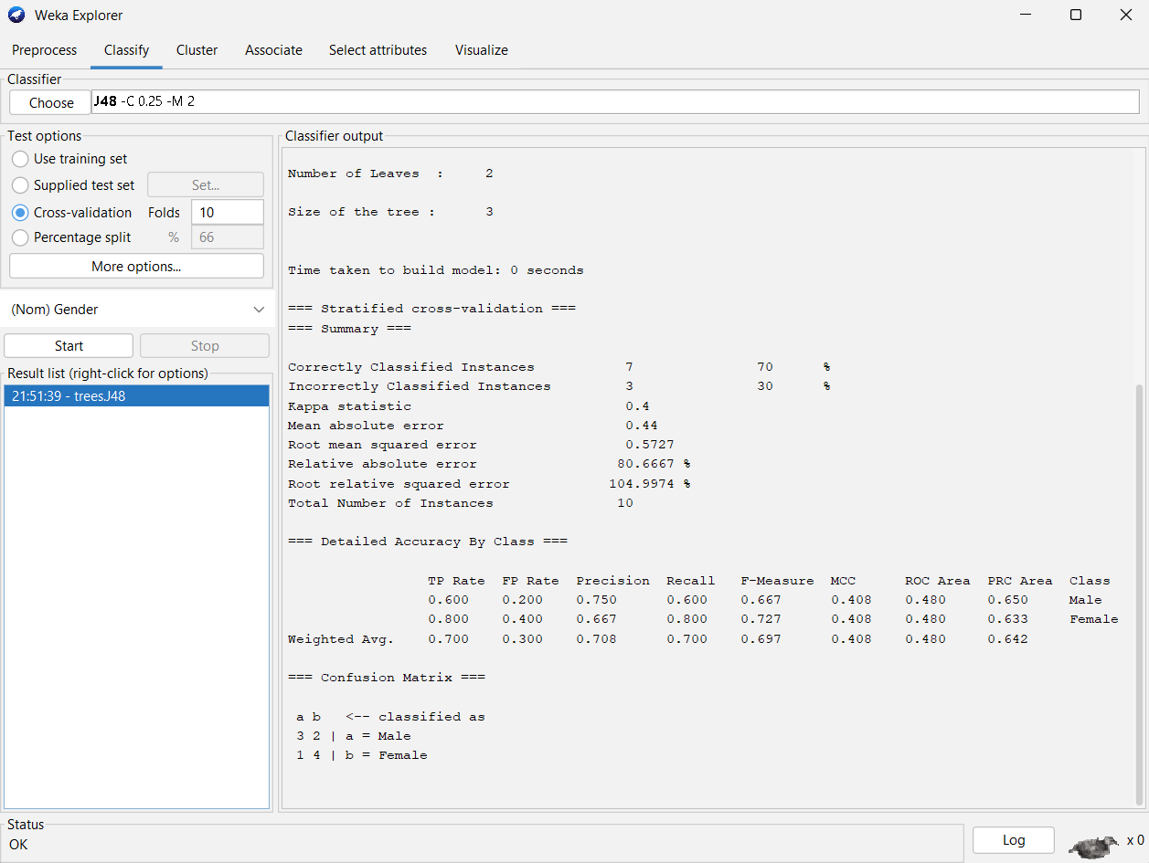
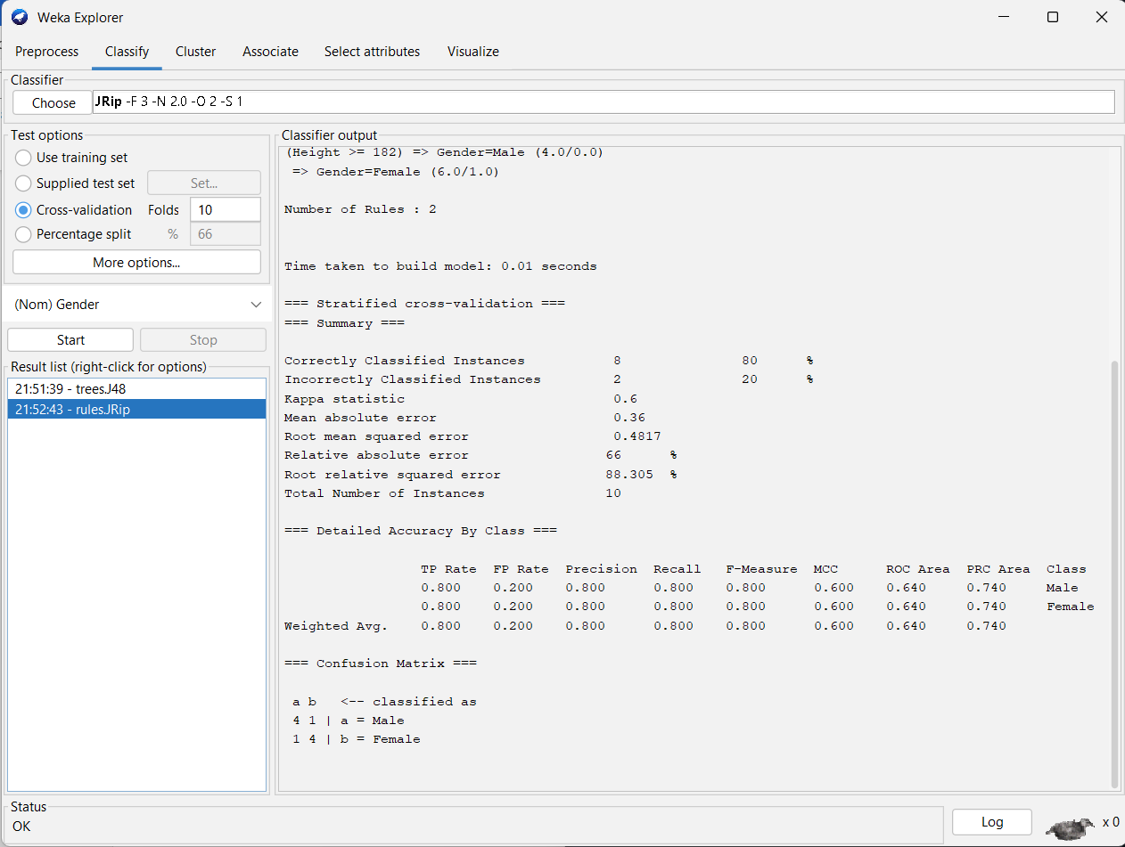
EXPERIMENT NO.:10
@relation electronics_transactions

@attribute SONY {t,f}
@attribute BPL {t,f}
@attribute LG {t,f}
@attribute SAMSUNG {t,f}
@attribute ONIDA {t,f}

@data
t,t,t,f,f
f,t,f,t,f
f,t,f,f,t
t,t,f,t,f
t,f,f,f,t
f,t,f,f,t
t,f,f,f,t
t,t,t,f,t
t,t,f,f,t
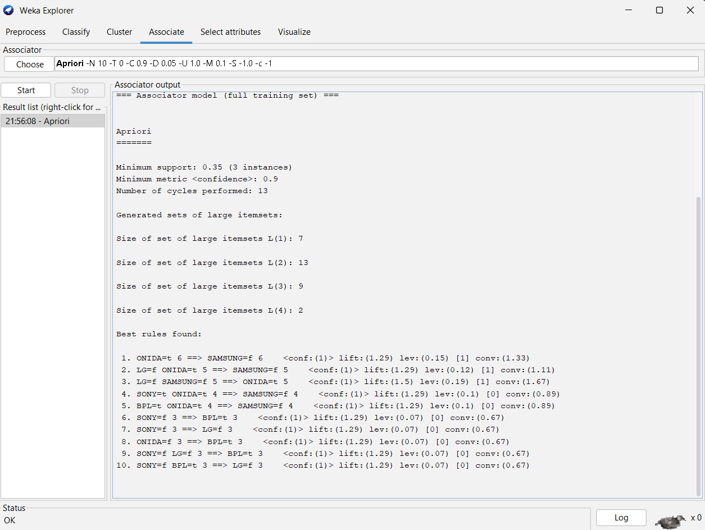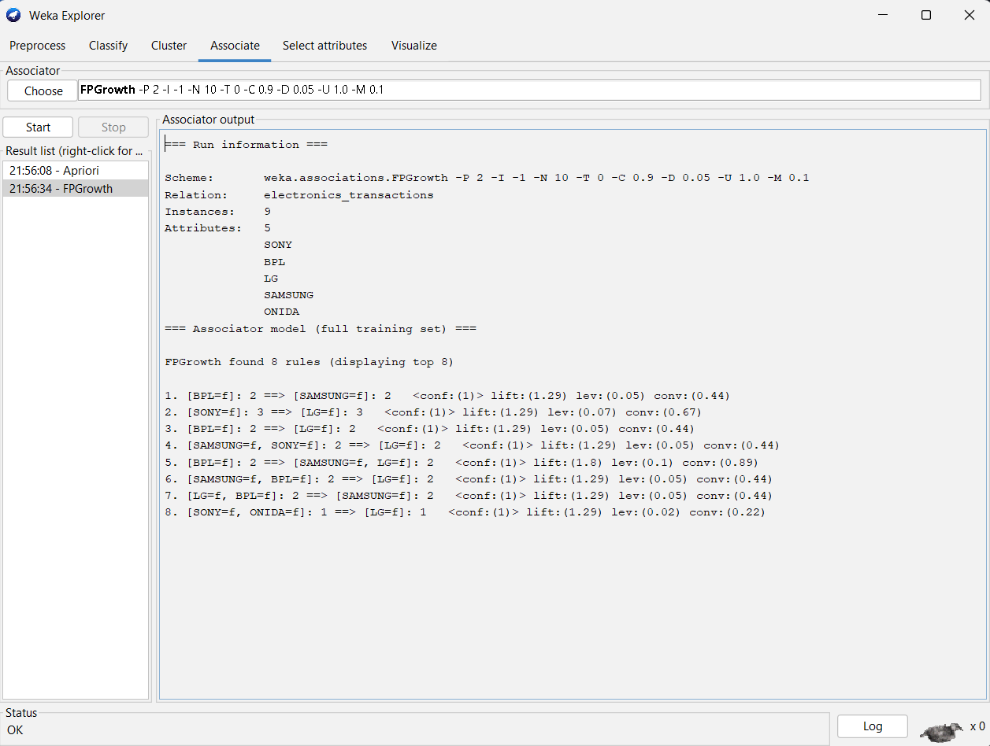

EXPERIMENT NO.:12
@relation strike_rate

@attribute StrikeRate numeric

@data
100
70
60
90
90
